EBIT Run November 18-19, 2016:

Goals:

1. To measure and describe the dielectronic recombination processes precisely and to better match the theory with the experiment, the Ge detector has to be well calibrated. For this purpose, we intend to load different gases through the gas injection setup (Ar and Kr in this case) and the background gases (Xe and Ba). The strong spectral lines from these elements are well known and hence can be utilized for calibration purposes.

2. On May 2016, we measured dielectronic-recombination processes in highly charged W ions with the EBIT at NIST. The spectra were recorded with the Ge detector for the beam energies from 6.44 keV through 11.27 keV and the non-Maxwellian collisional radiative modeling code that included more than 50000 energy levels and 0.8 million radiative transitions was used to analyze and identify the strong emission features of LMn and LNn DR resonances from Mn-like through Ne-like tungsten. Some of the features weren’t well explained by this model and a new refined model which takes into account configurations up to n=15, and includes double the energy levels and radiative transitions compared to the first model was developed to further analyze and resolve all the features that were measured. The advancement in the theoretical model for an element as heavy and complex as W (Z=74) motivated us to continue the measurements for elements that are as heavy as or heavier than W. With the current MEVVA cathodes, the available options are Yb (Z=70) and Bi (Z=82). We intend to measure the DR processes by tuning the electron beam energies to resonant energies for Yb and Bi. As we make successive energy scans, we can measure emission spectra from radiative recombination and direct excitation processes as well.

3. NIST EBIT has succeeded to measure unidentified line features for over two decades and still continues to provide critical spectroscopic data to different research communities. Recent interests for line identification for higher charge states of heavy elements has motivated us to move to higher Z end. EBIT has the capability to strip electrons to bare nuclei with the accessibility of electron beam energy of few hundred eVs up to 30 keV. This allows us to measure transitions for the N-, M- and L- shell ions for Yb. Furthermore, Yb belongs to the lanthanide series which have gathered much interest over the years. In this work, we have measured the Ni-like through Rb-like Yb spectral lines and have been able to identify more than 100 new transitions.

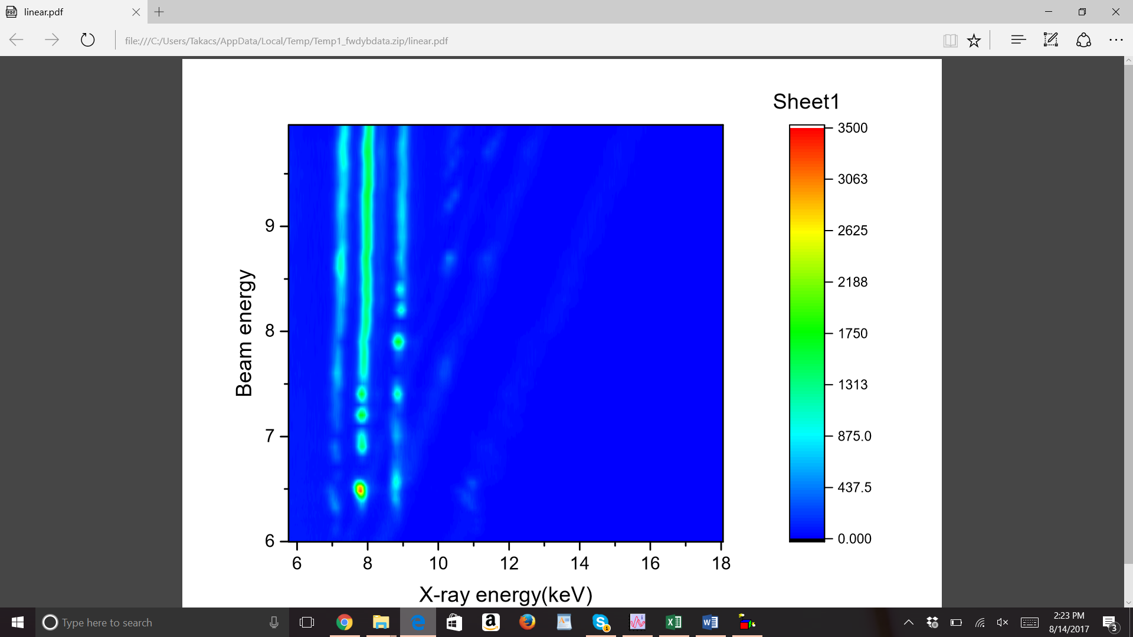Linear scale

Log Scale:

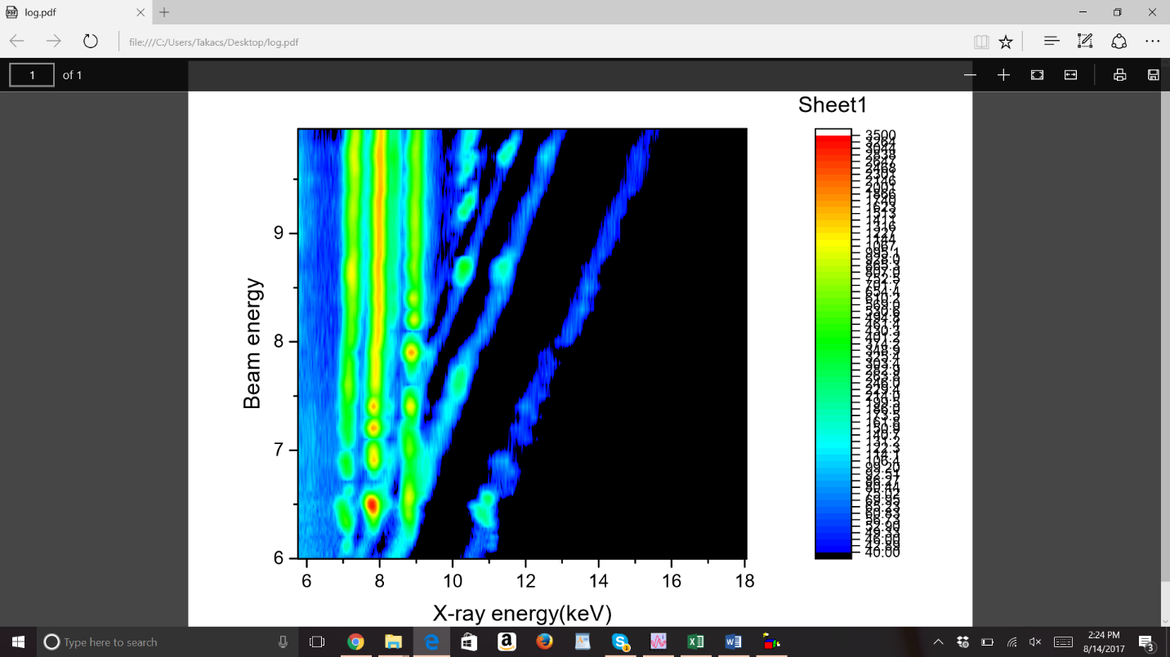

|  |  |
| --- | --- |
| Table 1: EBIT settings 11/18/2016 | |
| Beam line Pressure (Torr) | 2.00E-09 |
| e- gun pressure (Torr) | 1.70E-10 |
| crystal spectrometer (Torr) |  |
| Mevva section (Torr) | 1.90E-08 |
| Big 3 (Torr) | 2.00E-09 |
| Bender #1 (Torr) | 5.30E-09 |
| Bender #2 (Torr) | 5.30E-09 |
| Mirror Chamber; Cathode (Torr) | 1.00E-08 |
| Grating Chamber; Cathode (Torr) | 1.00E-10 |
| Mirror Chamber (Torr) | 2.10E-08 |
| Grating Chamber (Torr) | 6.00E-09 |
| Gas injection pressure (Torr) | 2.00E-08 |
| Super Magnet resistance (Ohm) | 0 |
|  |  |
| Focus (v) | 15 |
| suppressor (v) | 610 |
| einzel lens (v) | 1240 |
| extractor (v) | 2400 |
| Transition (v) | 5.46 |
| filament (v) | 6.3 |
| filament (amp) | 0.495 |
| TC1 (collector exhaust) °F | 315 |
| UDT (v) | 500 |
| LDT (v) | 260 |
| MDT (v) | 400 while dumping, 0 for trap |
| Collector magnet voltage (V) | 5.18 |
| collector magnet current (A) | 0.539 |
| SC magnet current (A) | 147.8 |
| Bucking coil voltage (v) | 0.54645 |
| snout (μA) | 19.4 |
| collector voltage (2kV) | 2 |

Day 1 (11/18/2016):

As an effort to calibrate the germanium detector, background spectra were collected with both the Ge detector and the crystal spectrometer. Xe lines are expected to be seen from previous measurements as Xe is heavy and sticks around the trap if the trap isn’t dumped. Similarly, Ba lines are seen in the spectra which comes from the electron gun. Measurements were also taken with the crystal spectrometer by adjusting the values of sine of the Bragg angle such that the photon energy matches the strong Xe and Ba lines as listed in Table 2. In addition to the Xe and Ba lines, spectral lines from Ar and Kr were also recorded with the x ray detectors. Ar and kr gas was injected at a pressure of 1.5 x 10-5 torr. The beam energy, Bragg angle and other settings during the acquisition has been listed in Table 3 and Table 4.

Table 2:

|  |  |  |  |
| --- | --- | --- | --- |
| line | ev | Angstrom | sin (x) |
| xe 1 | 4215.59 | 2.941087662 | 0.7353 |
| Xe 2 | 4557.78 | 2.720276042 | 0.6801 |
| Ba 1 | 4568.9 | 2.713655308 | 0.6784 |
| Ba 2 | 4938.5 | 2.510563883 | 0.6276 |
| Xe 3 | 5146.09 | 2.409289332 | 0.6023 |
| Ba 3 | 5295.8 | 2.341179754 | 0.5853 |
|  | 6800 | 1.82329702 | 0.4558 |
|  | 7201 | 1.721763608 | 0.4304 |
|  |  |  |  |

Table 3:



Table 4:



We found problems with the Bi cathode as it began misfiring at floating voltages higher than 3 keV. Even after multiple days of training the Bi cathode, it kept misfiring at the floating voltage higher than 3 keV. It was noted that after the cathodes were replaced in 2014, Bi cathode hasn’t been functioning well which could be due to misaligned cathode geometry. We continue to investigate the dielectronic recombination processes both experimentally and theoretically. By scanning the beam energies from 6 keV through 10 keV by steps of 50 eV or less, we should be able to resolve the strongest resonant processes including the features from direct excitation and radiative recombination as shown by the contour plots above.

LMn and LNn DR Processes were measured for Yb by varying the electron beam energies from 6 keV to 10 keV. Steps of 40 eV were taken increasing from 6 to 10 keV. The data were collected for 3 minutes with the crystal spectrometer, 2 minutes with the Ge detector and 2.5 minutes with the EUV spectrometer. Table 5 lists the acquisition settings as well as the electron beam energies and currents during the experiment.



Day 2 (11/19/2016):

On day 2, we continued with the DR measurements by scanning through the electron beam energies in the other direction compared to day 1. The energy were then dropped by steps of 100 eV beginning at the beam energy of 9.93 keV up to 5.96 keV. The data was acquired for 9 mins (3x3) with the crystal spectrometer, 8 mins (2x4) with the Ge detector and 10 mins (10x1) with the EUV spectrometer. Ne was injected at a pressure of 1.67 x 10-5 torr for calibration of the EUV spectrometer.





Yb spectra were recorded at beam energies of 3.76 keV, 3.6 keV and 3.2 keV. As the beam energy is lowered, the beam current dropped to 110 mA from 150 mA. Changing the voltage of the focus electrode helped maintain comparatively higher current at low voltages. The EUV CCD position was changed to 0.994” (4 nm to 20 nm range) from 0.675” (7.5 nm to 26 nm range) at the beam energy of 3.21 keV to cover the lines of interest in the lower wavelength region. Spectra were acquired for 10 minutes with the EUV spectrometer from 3.21 keV through 1. 61 keV. Ne was injected for calibration purpose at the beam energy of 4 keV and the spectra was collected for 5 minutes. Similarly, background spectra which consists of the Xe and Ba lines were recorded for 5 minutes. Fe ions were loaded into the trap from MEVVA for calibration purpose as well. We measured the N-shell (Rb-like through Ni-like) Yb spectral lines by systematically varying the beam energies from 1.71 keV to 3.21 keV.